- Copyright for test papers and marking guides remains with West Australian Test Papers.
- The papers may only be reproduced within the purchasing school according to the advertised conditions of sale.
- Test papers must be withdrawn after use and stored securely in the school until 10th October.

CHEMISTRY
UNITS 3 & 4
2024

MARKING GUIDE

TIME ALLOWED FOR THIS PAPER

Reading time before commencing work: Ten minutes
Working time for the paper: Three hours

MATERIALS REQUIRED/RECOMMENDED FOR THIS PAPER

To be provided by the supervisor:
This Question/Answer Booklet
Multiple-choice Answer Sheet
Chemistry Data Book

To be provided by the candidate:
Standard items: pens, pencils, eraser or correction fluid, ruler, highlighter.

Special items: calculators satisfying the conditions set by the SCSA for this subject.

IMPORTANT NOTE TO CANDIDATES
No other items may be taken into the examination room. It is your responsibility to ensure that you do not have any unauthorised notes or other items of a non-personal nature in the examination room. If you have any unauthorised material with you, hand it to the supervisor before reading any further.

Structure of this paper

Section | Number of questions available | Number of questions to be answered | Suggested working time  (minutes) | Marks available | Percentage of exam
Section One  Multiple-choice | 25 | 25 | 50 | 25 | 25
Section Two  Short answer | 10 | 10 | 60 | 76 | 35
Section Three  Extended answer | 5 | 5 | 70 | 88 | 40
 |  |  |  | Total | 100

Section One: Multiple-choice 25% (25 marks)

1 | a □ b ■ c □ d □ |  | 6 | a ■ b □ c □ d □ |  | 11 | a □ b ■ c □ d □
2 | a □ b □ c ■ d □ |  | 7 | a □ b □ c ■ d □ |  | 12 | a ■ b □ c □ d □
3 | a □ b □ c ■ d □ |  | 8 | a □ b ■ c □ d □ |  | 13 | a □ b □ c □ d ■
4 | a □ b □ c ■ d □ |  | 9 | a ■ b □ c □ d □ |  | 14 | a ■ b □ c □ d □
5 | a □ b □ c □ d ■ |  | 10 | a □ b □ c □ d ■ |  | 15 | a □ b ■ c □ d □

16 | a □ b □ c □ d ■ |  | 21 | a □ b ■ c □ d □
17 | a □ b □ c □ d ■ |  | 22 | a □ b □ c ■ d □
18 | a ■ b □ c □ d □ |  | 23 | a □ b □ c □ d ■
19 | a ■ b □ c □ d □ |  | 24 | a □ b □ c ■ d □
20 | a □ b ■ c □ d □ |  | 25 | a □ b ■ c □ d □

Section Two: Short answer 35% (76 marks)

Question 26 (6 marks)

(a) Justify whether this equation represents the chemical reaction taking place during the ‘recharge’ or ‘discharge’ cycle of the lead-acid accumulator. Use standard reduction potential data to support your answer. (4 marks)

Description | Marks
Relevant SRP table data:  PbSO₄(s) + 2 e⁻ → Pb(s) + SO₄²⁻(aq) E⁰(red) = –0.36 V  PbSO₄(s) + 2H₂O(l)→PbO₂(s) + SO₄²⁻(aq) + 4H⁺(aq) + 2e⁻ E⁰(ox) = –1.69 V  or  PbO₂(s) + SO₄²⁻(aq) + 4H⁺(aq) + 2e⁻→PbSO₄(s) + 2H₂O(l) E⁰(red) = +1.69 V  PbSO₄(s) + 2 e⁻ → Pb(s) + SO₄²⁻(aq) E⁰(red) = –0.36 V | 1
EMF = –0.36 – 1.69 = –2.05 V | 1
Recognition that a negative EMF corresponds to a non-spontaneous reaction / to a requirement for electrical energy input. | 1
Recognition that the reaction therefore represents the recharge cycle. | 1
Total | 4

(b) State one use of the lead-acid accumulator. (1 mark)

Description | Marks
Any one (1) of the following uses;  - car / vehicle battery  - electric scooters / wheelchairs / bicycles  - boat battery  - electric forklifts  - golf carts  - submarines  - back up power supplies  - lighting | 1
Total | 1

(c) Identify one safety concern associated with the lead-acid accumulator. (1 mark)

Description | Marks
Any one (1) of the following safety concerns;  - lead is poisonous / a neurotoxin  - sulfuric acid electrolyte is corrosive / may cause skin burns  - environmental concerns of disposal  - potential to get an electric shock | 1
Total | 1

Question 27 (8 marks)

(a) A solution of potassium hydroxide was added dropwise to a beaker containing aqueous propanoic acid. (2 marks)

Description | Marks
CH₃CH₂COOH(aq) + OH⁻(aq) → H₂O(l) + CH₃CH₂COO⁻(aq)
Correct species | 1
Correct balancing | 1
Total | 2
Note: state symbols are not required for full marks.

(b) Chlorine gas is bubbled through a solution of 0.1 mol L⁻¹ sodium iodide. (2 marks)

Description | Marks
Cl₂(g) + 2 I⁻(aq) → I₂(aq) + 2 Cl⁻(aq)
Correct species | 1
Correct balancing | 1
Total | 2
Note: state symbols are not required for full marks.

(c) A piece of cobalt metal is placed into a beaker containing excess 0.5 mol L⁻¹ sulfuric acid solution. (2 marks)

Description | Marks
Silver solid dissolves in colourless solution | 1
Effervescence / bubbling as pink solution forms | 1
Total | 2

(d) A 1 mol L⁻¹ nickel chloride solution is poured over some small pieces of lead metal. (2 marks)

Description | Marks
Green solution added to grey solid | 1
No change observed / no visible reaction | 1
Total | 2

Question 28 (7 marks)

(a) Complete the table above by writing the IUPAC name for each compound. (3 marks)

Description |  | Marks
A | methyl ethanoate | 1
B | propanamide | 1
C | 4,4-dibromobutan-2-one | 1
Total |  | 3

(b) State which compound is likely to have the highest solubility in water. Explain your answer in terms of intermolecular forces. (4 marks)

Description | Marks
Compound B / propanamide | 1
Recognition that compound A, B and C are all able to form hydrogen bonds with water. | 1
Recognition that when hydrogen bonds between compound B and water form, this would release more energy than when hydrogen bonds form between compound A and C and water. | 1
Recognition that this would allow a greater number of attractions, between molecules of compound B and between molecules of water, to be disrupted (resulting in the highest solubility). | 1
Total | 5

Question 29 (4 marks)

A sample of pure water was stored in the fridge at a temperature of 4.0 °C. The pH of this water was measured using a digital pH meter and found to be 7.39.

Calculate the value of K_{w} at 4.0 °C.

Description | Marks
[H⁺] = 10^{-7.39}  = 4.0738 x 10⁻⁸ mol L⁻¹ | 1
= [OH⁻] | 1
K_{w} = [H⁺] [OH⁻] | 1
= 1.7 x 10⁻¹⁵ | 1
Total | 4

Question 30 (6 marks)

(a) Identify whether this species represents a soap or detergent. (1 mark)

Description | Marks
Soap | 1
Total | 1

(b) Add to the diagram above, to show how this species interacts with both fat and water.
Your diagram should include;
- one fat molecule
- one water molecule
- labels showing the predominant type of forces acting between this species and the fat and water molecules. (5 marks)

Description | Marks
Fat molecule drawn correctly (may be structural, condensed, skeletal) | 1
Dispersion forces between fat and non-polar tail labelled | 1
Water molecule drawn correctly | 1
Ion-dipole forces between water and polar head labelled | 1
Water molecule oriented correctly towards carboxylate ion | 1
Total | 5

Question 31 (11 marks)

(a) Write the equilibrium constant expression for this reaction. (2 marks)

Description | Marks
[Fe²⁺] [H₂S]  [H⁺]²  K = | 2
Total | 2
Note: award 1 mark for minor error, such as missing ion charge

(b) Complete the following table by stating how each of the imposed changes would affect;
(i) the rate of the forward reaction, and
(ii) the position of equilibrium. (4 marks)
Note: consider the effect of each of these changes in isolation.

Description | Marks
Rate of forward reaction Position of equilibrium  The partial pressure of H₂S(g) was increased. increased shift right  A sample of distilled water was added. decreased shift right  Award 1 mark per correct cell. | 4
Total | 4

(c) On the grid below, continue the curves to illustrate the concentration changes that would occur from Time T1 until after Time E2. (5 marks)

Description | Marks
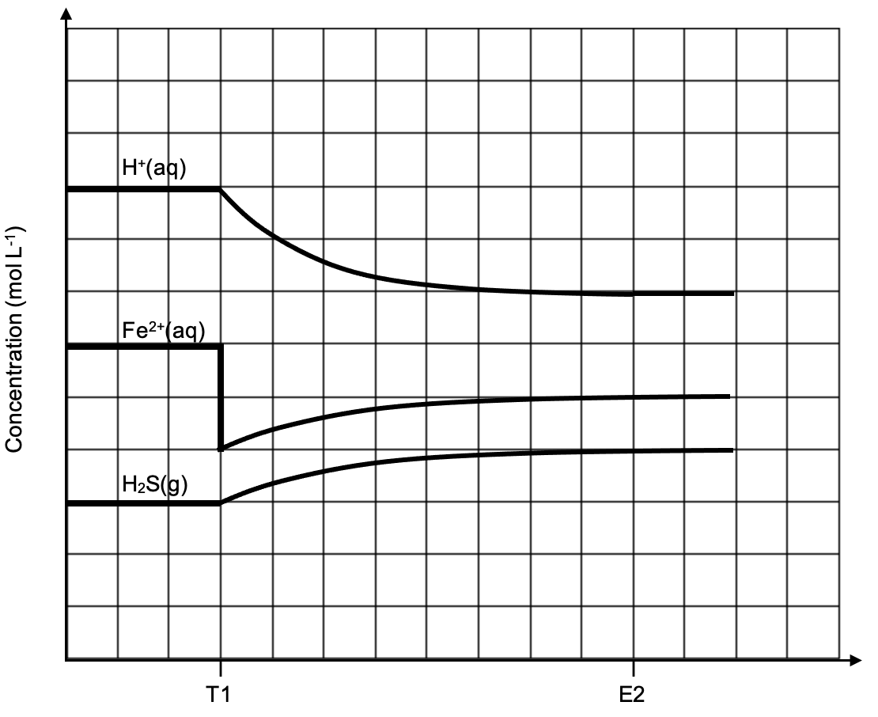

At T1; initial decrease for [Fe²⁺] | 1
Between T1 and E2; [H⁺] decreasing, [Fe²⁺] / [H₂S] increasing | 1
Between T1 and E2; gradient of [H⁺] twice that of [Fe²⁺] / [H₂S] | 1
At E2; all lines horizontal | 1
At E2; [Fe²⁺] concentration below original | 1
Total | 5

Question 32 (10 marks)

(a) Use this information to justify the statement below. Your answer should include relevant definitions and chemical equations. (6 marks)

“A conjugate acid is not always acidic.”

Description | Marks
Recognition that a conjugate acid is a species with one additional proton/H⁺ compared to another. | 1
Recognition that HCO₃⁻ is the conjugate acid of CO₃²⁻. | 1
Recognition that an acidic solution means [H₃O⁺] > [OH⁻] / an excess of H₃O⁺. | 1
Recognition that both HCO₃⁻ and CO₃²⁻ are basic because they hydrolyse with water to produce an excess of OH⁻. | 1
HCO₃⁻(aq) + H₂O(l) ⇌ H₂CO₃(aq) + OH⁻(aq) | 1
CO₃²⁻(aq) + H₂O(l) ⇌ HCO₃⁻(aq) + OH⁻(aq) | 1
Total | 6
Note: state symbols are not required for full marks.

(b) Explain how the buffering capacity of Buffer A and Buffer B would differ. (4 marks)

Description | Marks
Recognition that buffer A has a higher concentration of the acidic buffer species / HCO₃⁻. | 1
Recognition that buffer A would therefore have a greater buffering capacity upon addition of OH⁻(aq). | 1
Recognition that buffer B has a higher concentration of the basic buffer species / CO₃²⁻. | 1
Recognition that buffer B would therefore have a greater buffering capacity upon addition of H₃O⁺(aq). | 1
Total | 4

Question 33 (7 marks)

(a) Complete this reaction sequence, by drawing structural formulae for the organic compounds in the boxes labelled A, B, C and D. (4 marks)

Description |  | Marks
A |  | 1
B |  | 1
C |  | 1
D |  | 1
Total |  | 4

(b) Name the type of reaction occurring at; (3 marks)

Description |  | Marks
W | Addition / hydration / oxidation | 1
X & Y | Oxidation / redox | 1
Z | Esterification / condensation | 1
Total |  | 3

Question 34 (9 marks)

(a) Write balanced oxidation and reduction half-equations and an overall redox equation for this reaction. (5 marks)

Description | Marks
Oxidation half-equation:  Cr(s) → Cr³⁺(aq) + 3 e⁻ | 1
Reduction half-equation:
2 HOBr(aq) + 2 H⁺(aq) + 2 e⁻ → Br₂(aq) + 2 H₂O(l)
Correct species | 1
Correct balancing | 1
Overall redox equation:
2 Cr(s) + 6 HOBr(aq) + 6 H⁺(aq) → 2 Cr³⁺(aq) + 3 Br₂(aq) + 6 H₂O(l)
Correct species | 1
Correct balancing | 1
Total | 5
Note: state symbols are not required for full marks.

(b) In the boxes on the diagram below, use chemical formulae to label the substances that would be required to accomplish this cell design. Include state symbols. (4 marks)

Description | Marks
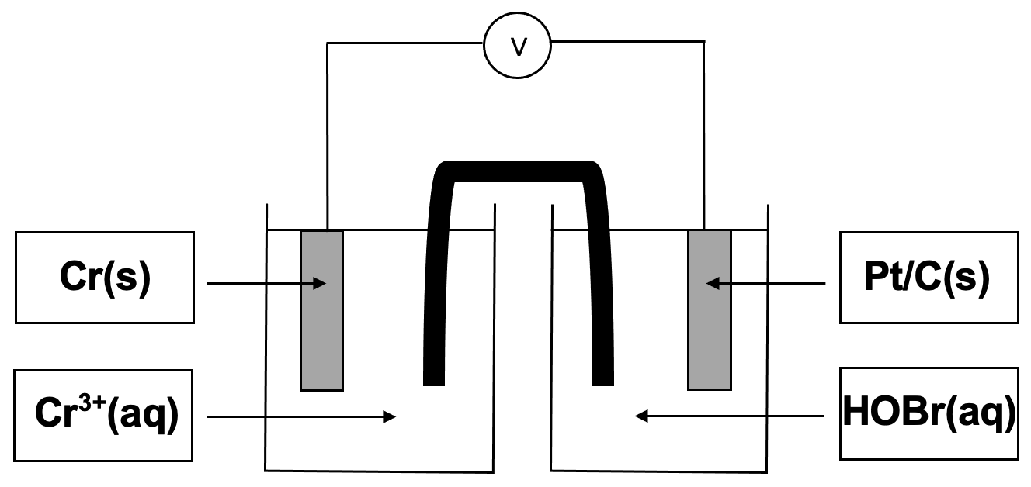  Award 1 mark per correct box. | 4
Total | 4
Note: half-cells may also be labelled in reverse, i.e. Cr(s) / Cr³⁺(aq) on the right side, Pt(s) / HOBr(aq) on the left side.

Question 35 (8 marks)

(a) Define a protein. (2 marks)

Description | Marks
Recognition that proteins are a sequence / polymer made from amino acid monomers. | 1
Recognition that proteins are folded into (a unique 3 dimensional) shape / have secondary and tertiary structures. | 1
Total | 2

(b) Define a catalyst. (2 marks)

Description | Marks
Recognition that a catalyst increases the reaction rate. | 1
Recognition that a catalyst is not used up in the reaction.  or  Recognition that a catalyst provides an alternate reaction pathway with a lower activation energy. | 1
Total | 2

(c) Which energy profile, A or B, represents this method? (1 mark)

Description | Marks
A | 1
Total | 1

(d) Identify a suitable catalyst used in this method. (1 mark)

Description | Marks
Zymase / yeast | 1
Total | 1

(e) Identify two (2) advantages of this catalyst, compared to the catalyst used in the hydration method. (2 marks)

Description | Marks
Any two (2) of many possible advantages, including;  - process performed at lower temperature  - process performed at lower pressure  - no corrosive acid catalyst used  - greener / more sustainable process  - process is more energy efficient  - saves money (using lower temperature and pressure)  - safer conditions for workers | 2
Total | 2

Section Three: Extended answer 40% (88 marks)

Question 36 (15 marks)

(a) Explain each of the following observations, with reference to collision theory and/or the concentration of relevant species where required.

(i) Initially, the colour of the gas mixture became a much darker brown. (2 marks)

Description | Marks
Recognition that a decrease in volume increases the concentration of all gaseous species / reduces the space between gas particles. | 1
Recognition that the darker brown colour is a result of increased NO₂(g) concentration. | 1
Total | 2

(ii) Subsequently, the brown colour of the gas mixture began to lighten. (5 marks)

Description | Marks
Recognition that there is an increased frequency of collisions between all species. | 1
Recognition that the forward and reverse reaction rates are both increased. | 1
Recognition that the forward reaction rate is increased to a greater extent than the reverse reaction rate. | 1
Recognition that the position of equilibrium shifts to the right / the forward reaction is favoured. | 1
Recognition that the lightening of the brown colour is due to the NO₂(g) being consumed faster than it is being produced / due to the decrease in concentration of NO₂(g). | 1
Total | 5

(iii) Finally, the shade of brown of the gas mixture remained the same. However, it was a darker brown than the original equilibrium mixture. (3 marks)

Description | Marks
Recognition that the rate of forward and reverse reactions are equal. | 1
Recognition that the brown colour does not change because the concentration of NO₂(g) is constant. | 1
Recognition that the colour remains darker than the original mixture because (the volume of the syringe is still less than originally, and thus) the concentration of NO₂(g) is still higher than in the original mixture. | 1
Total | 3

(b) Predict the effect this temperature increase would have on the value of K_{c}. Using Le Chatelier’s principle, justify your answer. (5 marks)

Description | Marks
Recognition that LCP predicts an increase in temperature will be partially opposed by favouring the direction that consumes heat. | 1
Recognition that the reverse / endothermic direction will be favoured. | 1
Recognition that this will result in an increased concentration of reactants / a decreased concentration of products. | 1
Recognition that K_{c} is equivalent to [products] / [reactants]. | 1
Recognition that K_{c} will decrease. | 1
Total | 5

Question 37 (20 marks)

(a) In addition to the three (3) fatty acids, name the other molecule required to form this triglyceride. (1 mark)

Description | Marks
Glycerol / propane-1,2,3-triol | 1
Total | 1

(b) Oleic acid and linoleic acid are classified as unsaturated fatty acids. What feature of their structure makes them unsaturated? (1 mark)

Description | Marks
Recognition that one or more double C=C bonds must be present. | 1
Total | 1

(c) State the most common catalyst that is used for this reaction. (1 mark)

Description | Marks
NaOH | 1
Total | 1

(d) Draw the structure of the most abundant biodiesel molecule that would be produced by this reaction. (2 marks)

Description | Marks
Ethyl group correctly shown | 1
Oleate chain correctly shown (may be structural, condensed, skeletal) | 1
Total | 2

(e) Which of the four amino acids mentioned, would not be able to participate in forming ionic bonds as part of the tertiary structure of arachin? (1 mark)

Description | Marks
Leucine | 1
Total | 1

(f) Draw a structural diagram showing the final three (3) amino acid residues in the arachin polypeptide. (3 marks)

Description | Marks
Correct amino acids used (i.e. correct side chains shown) | 1
Both peptide links correctly shown | 1
N terminus shown non-terminating, C terminus shown terminating | 1
Total | 3

(g) Determine the empirical formula of this amino acid, and thereby identify it. (11 marks)

Description | Marks
Calculating moles and mass of C | 2
Calculating moles and mass of H | 2
Calculating moles and mass of N | 2
Calculating moles and mass of O | 2
Determining simplest ratio by dividing all by smallest moles | 1
Writing empirical formula as C₅H₉NO₄ | 1
Stating amino acid is Glu | 1
Total | 11
 | C | H | N | O
mass (g) | (12.01 / 44.01) x 1.568  = 0.4279 | (2.016 / 18.016) x 0.5776  = 0.06463 | (9.52 / 100) x 1.048  = 0.09977 | 1.048 – (0.4279 + 0.06463 + 0.09977)  = 0.4557
moles (mol) | 0.4279 / 12.01  = 0.03563 | 0.06463 / 1.008  = 0.06412 | 0.09977 / 14.01  = 0.007121 | 0.4557 / 16.00  = 0.02848
ratio | 0.03563 / 0.007121 = | 0.06412 / 0.007121 = | 0.007121 / 0.007121 = | 0.02848 / 0.007121 =
 | 5 | 9 | 1 | 4

Empirical formula is C₅H₉NO₄. The identity of the amino acid is Glu.

Question 38 (16 marks)

(a) On the diagram above, circle and label two (2) different functional groups present in malic acid. (2 marks)

Description | Marks
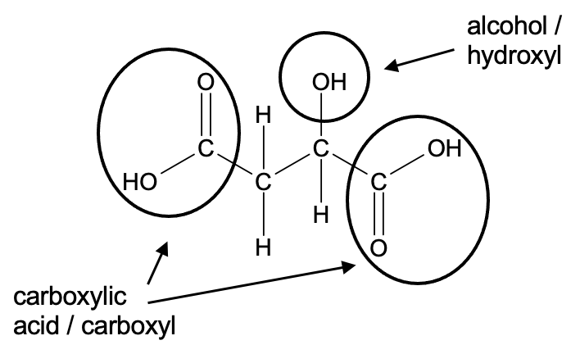

Alcohol / hydroxyl group circled and labelled correctly | 1
Either carboxylic acid / carboxyl group circled and labelled correctly | 1
Total | 2

(b) Explain why sodium hydroxide is not suitable to use as a primary standard. (2 marks)

Description | Marks
Recognition that a weighed mass of NaOH(s) cannot be accurately measured. | 1
Recognition that NaOH(s) is deliquescent / hygroscopic / reacts with water in the air / reacts with CO₂(g) in the air. | 1
Total | 2

(c) Determine the size of pipette that was used to prepare the HCl(aq) aliquots. Support your answer with relevant calculations. (4 marks)

Description | Marks
n(NaOH) = 0.08993 x 0.01812  = 0.0016295 mol | 1
= n(HCl) | 1
V(HCl) = 0.0016295 / 0.1086  = 0.01500 L | 1
A 15.00 mL pipette was used. | 1
Total | 4

(d) State the value, with uncertainty, of the volume of apple juice that was placed in the volumetric flask. (1 mark)

Description | Marks
75.00 ± 0.18 mL | 1
Total | 1

(e) Calculate the average titre. (1 mark)

Description | Marks
Using Trial 1, 2 and 4;  V(av. titre) = (6.25 + 6.21 + 6.14) / 3  = 6.20 mL | 1
Total | 1

(f) Calculate the concentration of malic acid in the apple juice, in grams per litre. (6 marks)

Description | Marks
n(NaOH) = 0.08993 x 0.0620  = 0.0005576 mol | 1
n(C₄H₆O₅ in 20 mL) = ½ x n(NaOH)  = 0.0002788 mol | 1
n(C₄H₆O₅ in 100 mL) = 0.0002788 x (100 / 20)  = 0.001394 mol | 1
= n(C₄H₆O₅ in 75 mL apple juice) | 1
m(C₄H₆O₅) = 0.001394 x 134.088  = 0.1869 g | 1
c(C₄H₆O₅) = 0.1869 / 0.075  = 2.49 g L⁻¹ | 1
Total | 6

Question 39 (15 marks)

(a) Write a chemical equation representing the hydrolysis of caprolactam. Use structural formulae for all organic compounds. (2 marks)

Description | Marks
Correct reactants | 1
Correct products | 1
Total | 2

(b) Explain why 6-aminohexanoic acid is not classified as an ‘α-amino acid’. (1 mark)

Description | Marks
The amine and the carboxyl group are not attached to the same carbon / the alpha carbon. | 1
Total | 1

(c) Define an isomer. (1 mark)

Description | Marks
Compounds with the same molecular formula but different structures. | 1
Total | 1

(d) Name, or give the three-letter symbols for, the two (2) α-amino acids that are isomers of 6-aminohexanoic acid. (2 marks)

Description | Marks
Isoleucine / Ile | 1
Leucine / Leu | 1
Total | 2

(e) Draw two (2) repeating units of the polymer nylon-6, which is formed by polymerisation of 6-aminohexanoic acid. (3 marks)

Description | Marks
Two repeating units shown | 1
Amide link correctly shown | 1
Non-terminating ends shown | 1
Total | 3

(f) What type of condensation polymer is nylon-6? (1 mark)

Description | Marks
Polyamide | 1
Total | 1

(g) Which of these products would nylon-6 be most suited for? Circle your choice below, and justify your answer in terms of the main property of nylon-6 which results in the desired characteristics. (2 marks)

Description | Marks
Carpet fibres (circled) | 1
Recognition that hydrogen bonds are present in polyamides / nylons (which would contain the desired characteristics for carpet fibre). | 1
Total | 2

(h) Define ‘crosslinking’ and explain how crosslinks are able to alter the properties of a polymer. (3 marks)

Description | Marks
Recognition that crosslinking involves the formation of covalent bonds between different polymer chains. | 1
Any two (2) of the following;  Recognition that crosslinks  - create a polymer network.  - increase the molar mass of the polymer molecules.  - increase the melting point of the polymer.  - reduces the mobility of the polymer chains.  - increase the rigidity of the polymer. | 2
Total | 3

Question 40 (22 marks)

(a) Justify the temperature and pressure conditions used in the steam-methane reforming reaction. (6 marks)

Description | Marks
Recognition that 1000 °C constitutes use of a high temperature. | 1
Recognition that this will produce a fast rate of reaction. | 1
Recognition that this will produce a high yield of reaction, due to the endothermic / forward reaction being favoured. | 1
Recognition that 1500 kPa constitutes use of a moderate / compromise pressure. | 1
Recognition that the rate of reaction is decreased by a low pressure.  or  Recognition that the rate of reaction is increased by a high pressure. | 1
Recognition that the yield is decreased by a high pressure since the reverse reaction (which produces a smaller number of gaseous species) would be favoured.  or  Recognition that the yield is increased by a low pressure since the forward reaction (which produces a greater number of gaseous species) would be favoured. | 1
Total | 6

(b) Calculate the total mass of H₂(g) that was produced. State your answer to the appropriate number of significant figures. (7 marks)

Description | Marks
m(CH₄) = 612 x 10³ g | 1
n(CH₄) = 612000 / 16.042  = 38149.9 mol | 1
n(H₂ from Step 1) = 3 x 38149.9 x (92.7 / 100)  = 106094.8 mol | 1
n(H₂ from Step 2) = 38149.9 x (92.7 / 100) x (88.1 / 100)  = 31156.5 mol | 1
n(H₂ total) = 106094.8 + 31156.5  = 137251.2 mol | 1
m(H₂) = 137251.2 x 2.016  = 276699 g  = 2.77 x 10⁵ g or 277 kg | 1
Answer stated to 3 significant figures. | 1
Total | 7

(c) Determine which of the fuel cell reactants would run out first. Use relevant calculations to support your answer. (4 marks)

Description | Marks
V(O₂) = (21 / 100) x 1.84 x 10⁶  = 386400 L | 1
n(O₂) = ( 448 x 386400 ) / ( 8.314 x 305.65 )  = 68121 mol | 1
n(O₂ required) = ½ x n(H₂)  = ½ x 137251.2  = 68626 mol  or  n(H₂ required) = 2 x n(O₂)  = 2 x 68121  = 136242 mol | 1
Therefore O₂(g) is the LR, since n(O₂) < n(O₂ required)  (i.e. 68121 mol < 68626 mol)  or  Therefore O₂(g) is the LR, since n(H₂) > n(H₂ required)  (i.e. 137251 mol > 136242 mol) | 1
Total | 4
Note: award follow through marks from part (b)

(d) Explain why a fuel cell is classified as a galvanic cell, but is neither a primary nor secondary cell. (2 marks)

Description | Marks
Recognition that a fuel cell is galvanic because it produces electricity from a spontaneous redox reaction. | 1
Recognition that a fuel cell is not primary or secondary because reactants need to be continuously fed into the cell. | 1
Total | 2

(e) Identify whether H₂(g) enters the hydrogen fuel cell at the anode or the cathode. Justify your answer, with the use of oxidation numbers. (3 marks)

Description | Marks
Hydrogen enters at the anode. | 1
Recognition that oxidation always occurs at the anode of an electrochemical cell. | 1
Recognition that the oxidation number of H₂ increases from (0) to (+1) in H₂O, thus H₂ is oxidised. | 1
Total | 3

